Sample Social Media Posts
Sample Twitter Posts  (280 character limit, 257 character limit with links) | Sample Facebook Posts | Sample Instagram Posts
We oppose Prop 21, a flawed measure that will make California’s housing crisis even WORSE. Stand with us and vote NO on Prop 21 in November.  #NOonProp21  #AffordableHousing  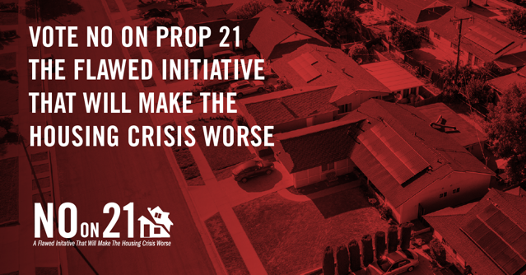 | We oppose Prop 21, a flawed measure that will make California’s housing crisis even WORSE. Stand with us and vote NO on Prop 21 in November.  #NOonProp21  #AffordableHousing  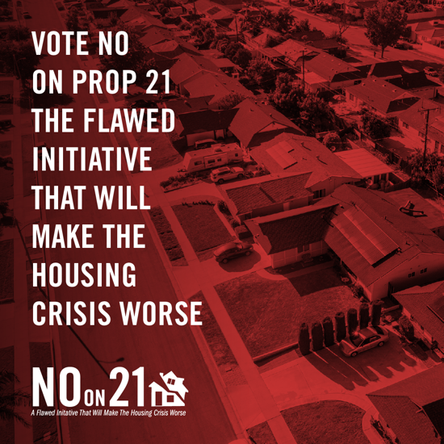 | We oppose Prop 21, a flawed measure that will make California’s housing crisis even WORSE. Stand with us and vote NO on Prop 21 in November. #NOonProp21 #AffordableHousing
We urge you to vote NO on Prop 21, a flawed measure that will make our housing crisis worse.  Join us in opposition!  https://noonprop21.org/join-the-coalition/  #NOonProp21  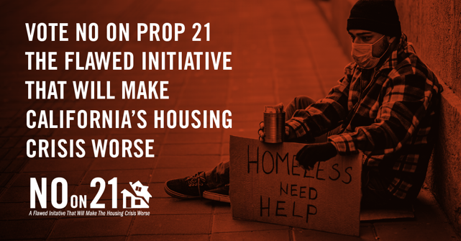 | We urge you to vote NO on Prop 21, a flawed measure that will make our housing crisis worse.  Join us in opposition!  https://noonprop21.org/join-the-coalition/  #NOonProp21  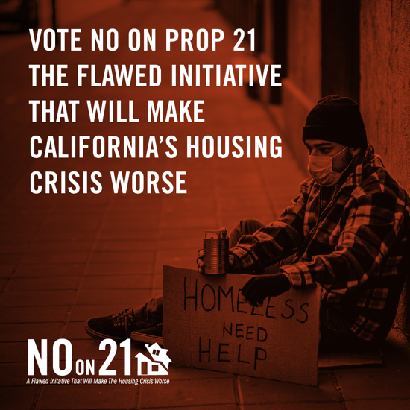 | We urge you to vote NO on Prop 21, a flawed measure that will make our housing crisis worse.  #NOonProp21
Why should you vote NO to Prop 21?  It will encourage landlords to remove their properties from the rental market, ultimately increasing evictions, decreasing the supply of rental housing, and raising the cost of housing for everyone.  #NOonProp21  #HousingCrisis | Why should you vote NO to Prop 21?  It will encourage landlords to remove their properties from the rental market, ultimately increasing evictions, decreasing the supply of rental housing, and raising the cost of housing for everyone.  #NOonProp21  #HousingCrisis
Did you know that Governor Newsom just signed a new 2020 law to protect renters from huge rent increases?  #Prop 21 repeals this new rent cap, leaving tenants across the state potentially unprotected from massive rent hikes.  Vote NO in November, and retweet to spread the word. | Did you know that Governor Newsom just signed a new 2020 law to protect renters from huge rent increases?  #Prop 21 repeals this new rent cap, leaving tenants across the state potentially unprotected from massive rent hikes.  Vote NO in November, and share with your friends to spread the word.  #NOonProp21
Read up on how #Prop21 will negatively impact all California renters, homeowners and taxpayers.  Prop 21 is a flawed measure that will make the housing crisis worse – and you deserve to know the truth.  #NOonProp21  https://noonprop21.org/facts/ | Read up on how #Prop21 will negatively impact all California renters, homeowners and taxpayers.  Prop 21 is a flawed measure that will make the housing crisis worse – and you deserve to know the truth.  #NOonProp21  https://noonprop21.org/facts/
Under Prop 21, local governments can give landlords the power to raise rents HIGHER than what’s allowed under current state law.  That doesn’t sound like renter protections to us. Vote NO and retweet if you agree. #NOonProp21 | Under Prop 21, local governments can give landlords the power to raise rents HIGHER than what’s allowed under current state law.  That doesn’t sound like renter protections to us. Vote NO and share if you agree. #NOonProp21
Prop 21 will put as many as 539 rental boards in charge of housing – with bureaucrats deciding what people can or can’t do with their property and adding fees that get passed on to tenants in the form of higher rents.  Vote #NoOnProp21!  #NOonProp21  #HousingCrisis | Prop 21 will put as many as 539 rental boards in charge of housing – with bureaucrats deciding what people can or can’t do with their property and adding fees that get passed on to tenants in the form of higher rents.  Vote #NoOnProp21!  #NOonProp21  #HousingCrisis
Do you think California needs higher housing costs, less new housing construction, more bureaucracy, and an even bigger budget deficit?  No?  Then you should vote NO on Prop 21. Spread the word!  #NoOnProp21 #AffordableHousing | Do you think California needs higher housing costs, less new housing construction, more bureaucracy, and an even bigger budget deficit?  No?  Then you should vote NO on Prop 21. Spread the word!  #NoOnProp21 #AffordableHousing
If Prop 21 passes, it will cost state and local governments millions of dollars. This could mean diverting funds from essential services, laying off workers, and raising taxes.  California cannot afford this flawed measure. Like if you’re voting #NOonProp21 | If Prop 21 passes, it will cost state and local governments millions of dollars. This could mean diverting funds from essential services, laying off workers, and raising taxes.  California cannot afford this flawed measure. Like if you’re voting #NOonProp21

